RDS

1. Create a maria db on ec2-instance.

I have created one ec2-instance and install mario-db and created username and password all the details and login into the db on instance level

This are the commands are used while installing maria-db on ec2 instance

sudo su -

yum -y install mariadb-server wget

systemctl enable mariadb

systemctl start mariadb

yum -y update

Set Environmental Variables

===========================

DBName=ec2db

DBPassword=admin123456

DBRootPassword=admin123456

DBUser=ec2dbuser

Database Setup on EC2 Instance:

===============================

echo "CREATE DATABASE ${DBName};" >> /tmp/db.setup

echo "CREATE USER '${DBUser}' IDENTIFIED BY '${DBPassword}';" >> /tmp/db.setup

echo "GRANT ALL PRIVILEGES ON *.* TO '${DBUser}'@'%';" >> /tmp/db.setup

echo "FLUSH PRIVILEGES;" >> /tmp/db.setup

mysqladmin -u root password "${DBRootPassword}"

mysql -u root --password="${DBRootPassword}" < /tmp/db.setup

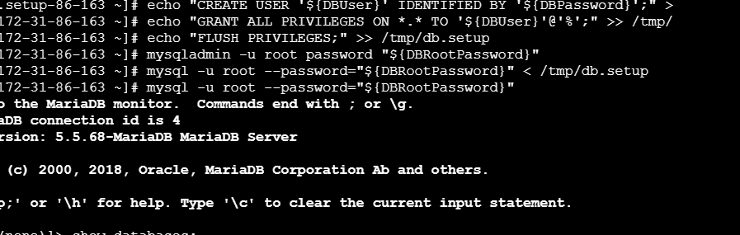

2) Insert some dummy data

After login into the instance on db i have dumped some data by creating tables on mariadb-ec2 instance

These are the commands i have used to create a table

mysql -u root --password="${DBRootPassword}"

USE ec2db;

CREATE TABLE table1 (id INT, name VARCHAR(45));

INSERT INTO table1 VALUES(1, 'Virat'), (2, 'Sachin'), (3, 'Dhoni'), (4, 'ABD');

SELECT * FROM table1;

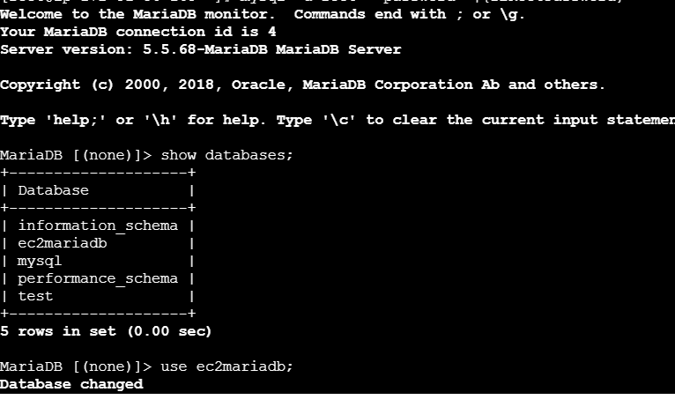

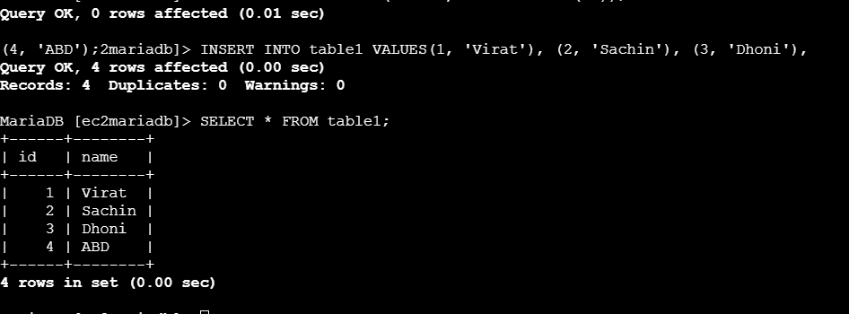

3) Take the backup of dummy data on ec2

After that i have taken the backup of my mariadb-ec2

1) Get the dump of your existing DB on EC2

mysqldump -u root -p database_name > file_name.sql

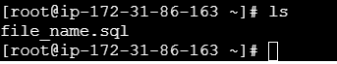

4) launch Mariadb RDS instance.

I have launched on Mariadb RDS using RDS services with configurations

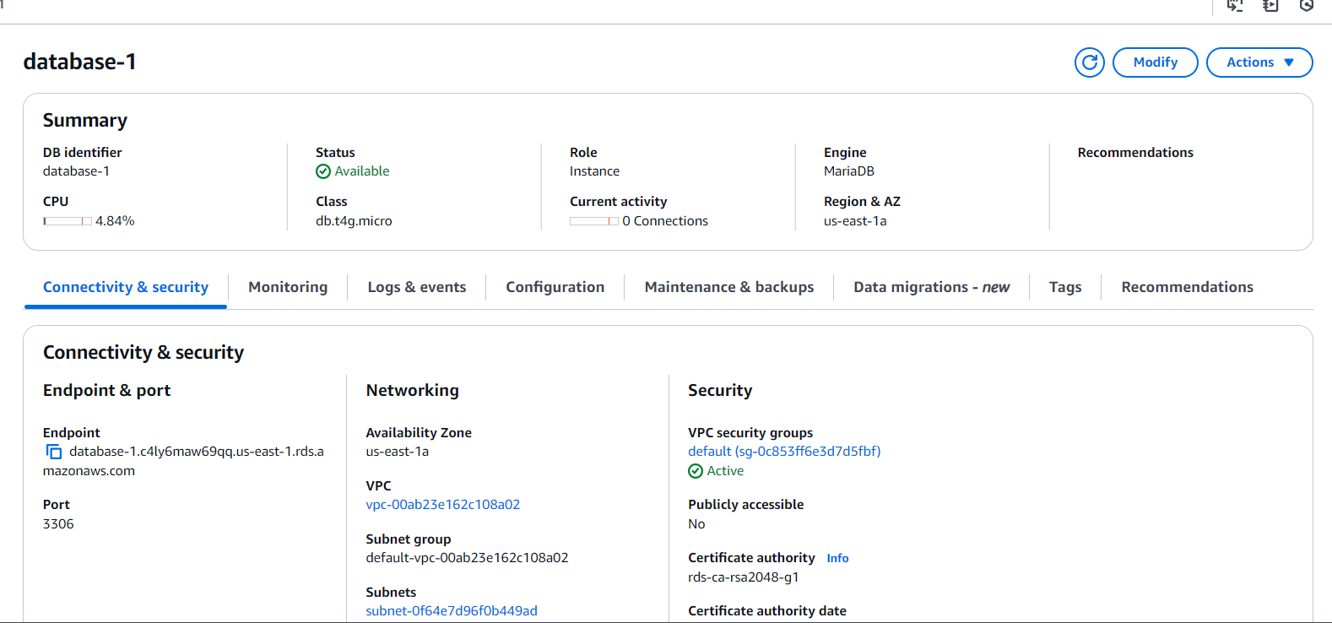

5) Migrate database from ec2 to RDS.

After connecting to the ec2-instance by using endpoint

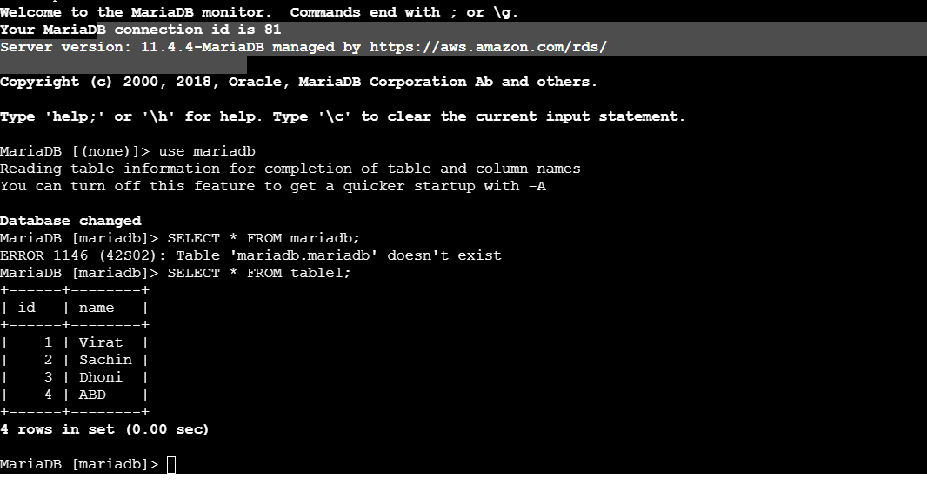

Migrate the DB dump that you have taken in step 1 to RDS

mysql -h <replace-rds-end-point-here> -P 3306 -u <user_name> -p database_name < ec2db.sql

Switch to the database and verify the details.

USE rdsdb

SELECT * FROM table1;

6) Install mysql db on ec2

I have installed mysql after removing all the mariadb on existing instance because they are both are running on the same port number we can’t run both on same. These are the commands i have used to install mysql on my ec2-instance

sudo yum install -y https://dev.mysql.com/get/mysql80-community-release-el7-5.noarch.rpm

sudo yum install -y https://dev.mysql.com/get/mysql80-community-release-el7-5.noarch.rpm

sudo yum install -y mysql-community-server

sudo yum-config-manager --disable mysql80-community

sudo yum-config-manager --enable mysql57-community

sudo yum install -y mysql-community-server

sudo systemctl start mysqld

sudo systemctl enable mysqld

sudo systemctl status mysqld

sudo cat /var/log/mysqld.log | grep "temporary password"

It will give temporary password

[Note] A temporary password is generated for root@localhost: A1b2C3d4E5f!

mysql -u root -p

After login we have to change our custom password

ALTER USER 'root'@'localhost' IDENTIFIED BY 'NewStrongPassword@123';

Step 3: Flush Privileges

EXIT;

mysql -u root -p

CREATE DATABASE mydb;

USE mydb;

CREATE TABLE employees (

id INT PRIMARY KEY AUTO_INCREMENT,

name VARCHAR(100) NOT NULL,

age INT,

department VARCHAR(50),

salary DECIMAL(10,2)

);

SHOW TABLES;

+------------+

| Tables_in_mydb |

+------------+

| employees |

+------------+

DESC employees;

INSERT INTO employees (name, age, department, salary)

VALUES ('John Doe', 30, 'IT', 60000.50);

SELECT * FROM employees;

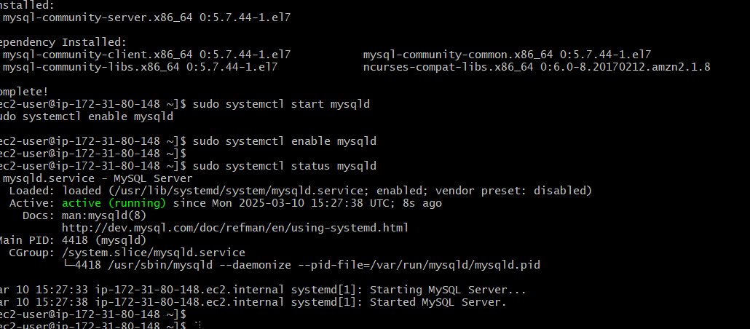

7) Launch mysql RDS image

I have launched mysql RDS image in my RDS services with dev configurations

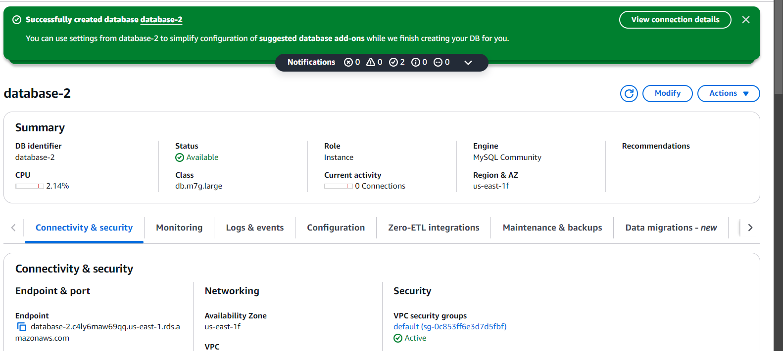

8) COnfigure multi AZ

While creating only we enable the multi AZ for the mysql DB

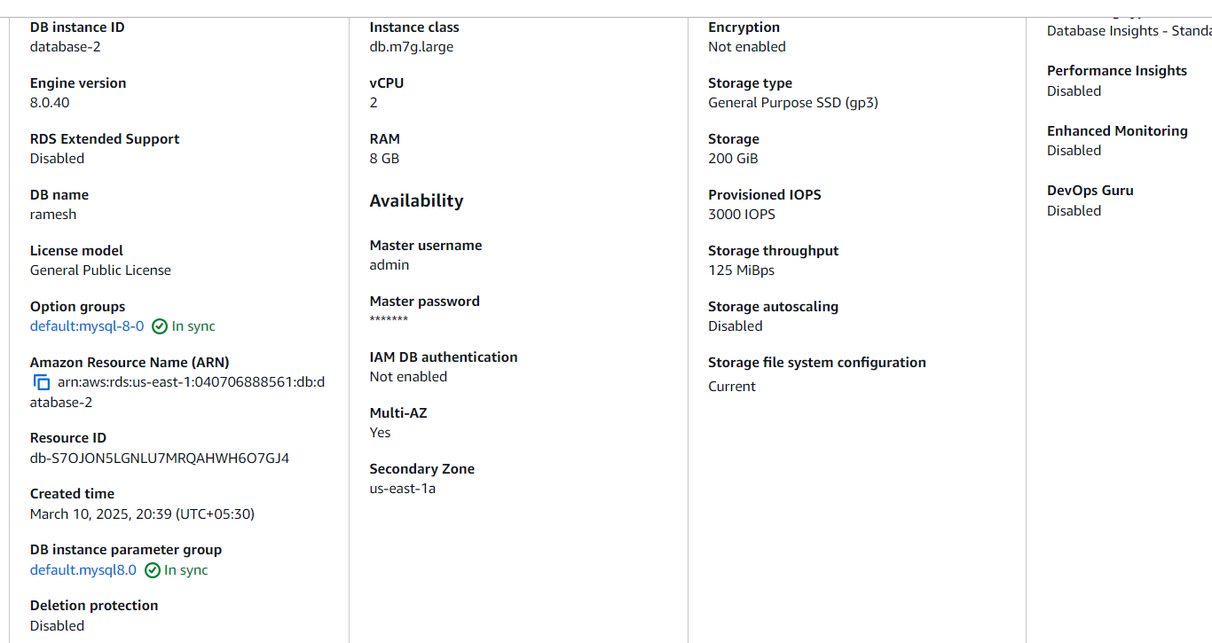

9) Take Backup of db and restore the DB

Step 1: Backup the Database

mysqldump -u root -p mydb > mydb_backup.sql

mydb → The database you want to back up.

mydb_backup.sql → The backup file that will be created.

-u root -p → Uses the root user (you will be prompted for a password).

Step 2: Restore the Database

To restore the database from the backup file:

1️. First, create the database (if it doesn’t exist):

mysql -u root -p -e "CREATE DATABASE mydb;"

2. Then, restore the backup:

mysql -u root -p mydb < mydb_backup.sql

This imports all data from mydb_backup.sql into mydb.

Step 3: Verify the Restoration

Log in to MySQL and check if the tables and data exist:

mysql -u root -p

USE mydb;

SHOW TABLES;

SELECT * FROM employees; -- If you have a table named 'employees'

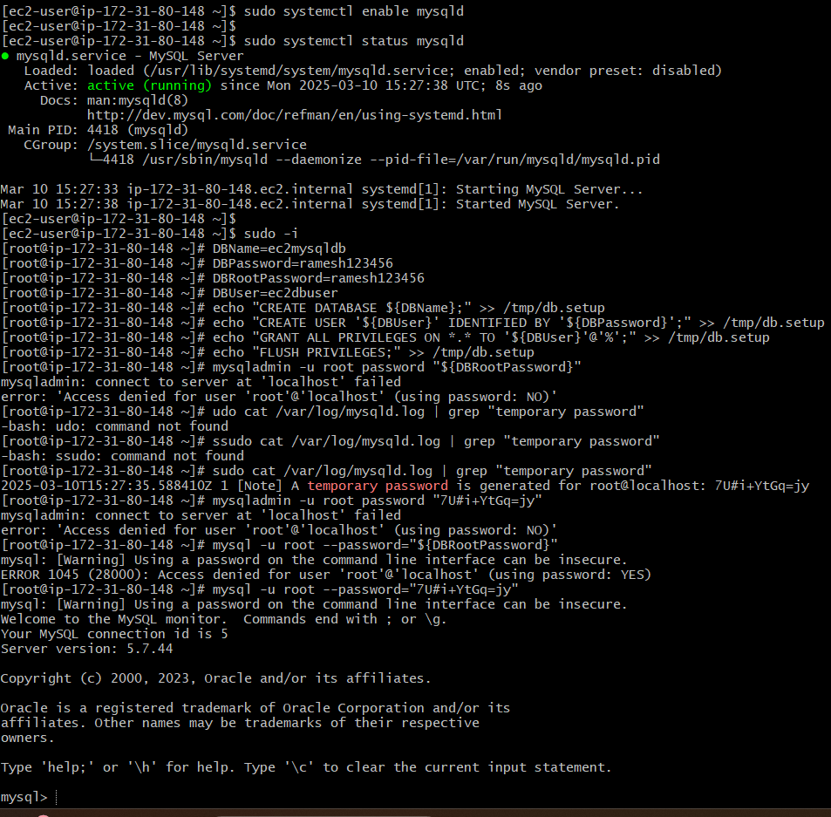

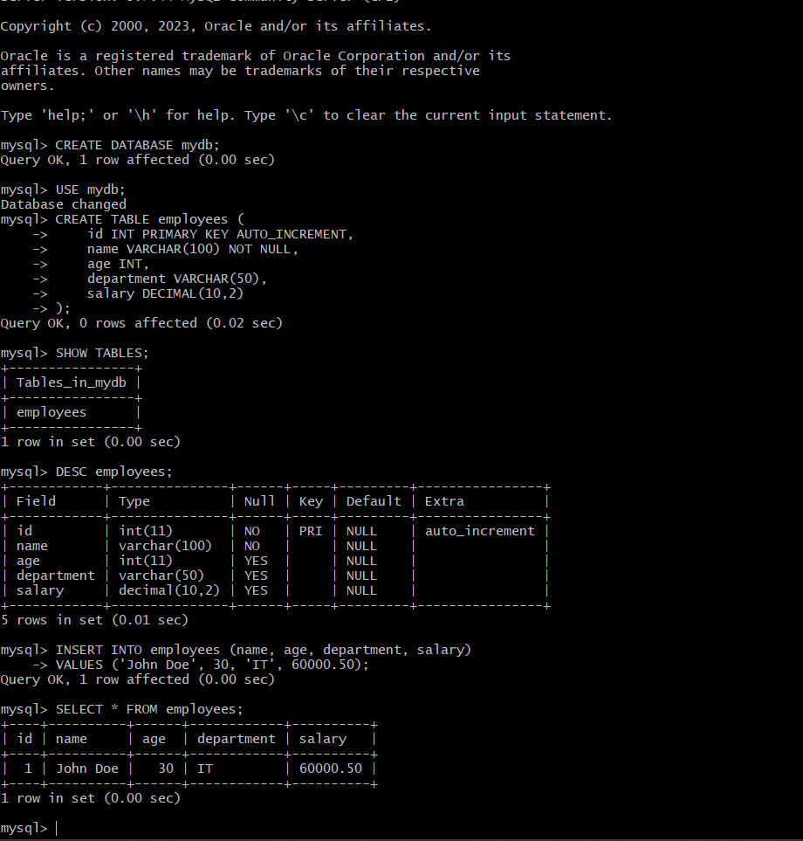

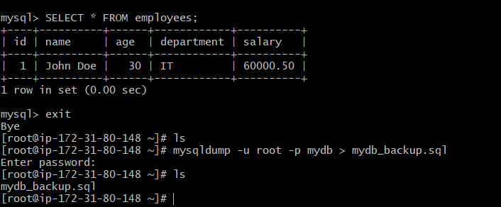

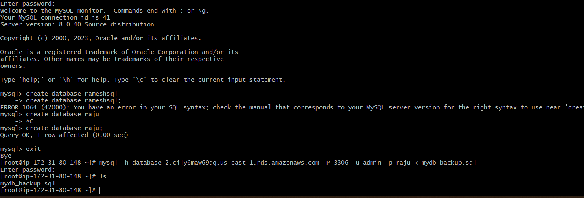

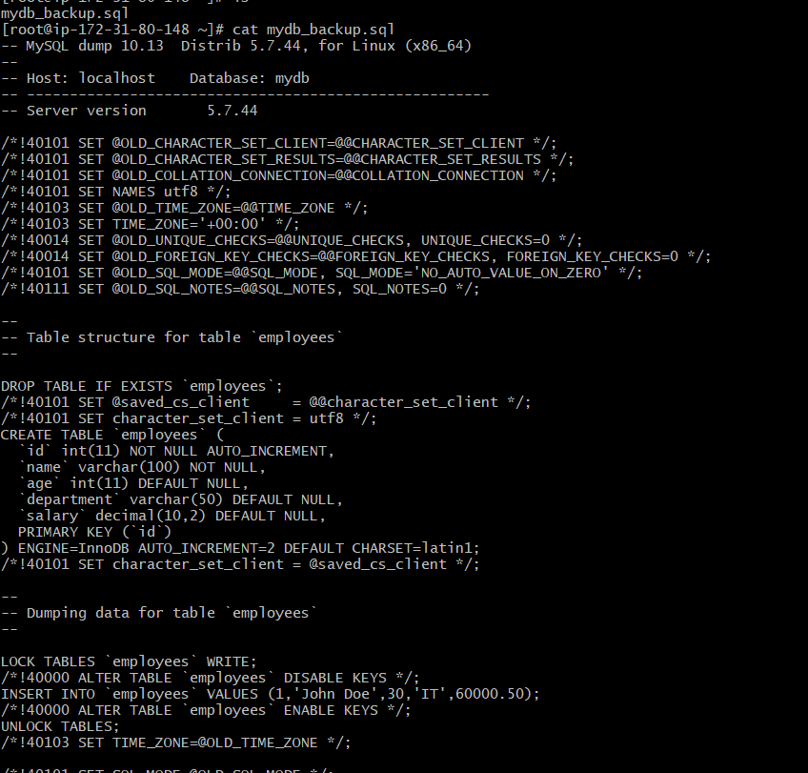

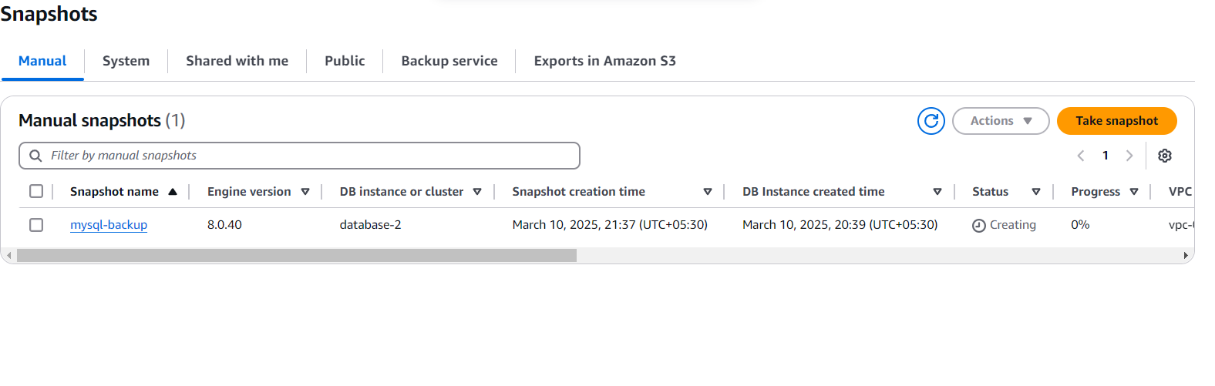

10) Create Read Replica

If we want to create a read Replica we need to modify the db instance and then option will be enabled to create a replica for the particular instance

